IMPORTANT COPYRIGHT INFORMATION ABOUT YOUR EDITABLE SCRIPT –
PLEASE READ
For your convenience, we have provided an editable script in Word format for this nativity
or musical. The sole purpose of the editable script is to allow you to adjust the allocation of speaking parts for smaller or larger cast sizes and/or to make minor changes to the text for staging purposes.

The provision of an editable script does not give permission to rewrite or make significant changes to the original script as provided in the PDF version in the eSongbook and in the printed Book. The original script has been carefully crafted and agreed between the writer and Out of the Ark Music and is a copyrighted work. Any significant changes to the wording, changes to the storyline, the nature of the characters, or the introduction of additional
material (in particular anything that could be considered defamatory, offensive or illegal),
are strictly prohibited by the Publisher. For nativities, this includes any changes to the presentation of the traditional Christmas story expressed in the original script.

Any adjustments that you make to the script, within the limitations and spirit of the conditions set out above, do not create a new work in which you have claims to any copyright.

Should you have questions about using this editable script, please contact our Customer Service team on 020 841 7200.

SCRIPT

SCENE 1

BETHLEHEM: OPENING NIGHT AT THE INN

The scene on stage is somewhat chaotic, with various items strewn about (see Staging, page 5). Sam and Samantha run back and forth across the stage a few times, looking stressed, maybe occasionally bumping into one another. They need to be offstage when the SFX Smash occurs.
SFX: Smash (Crockery) CD TRACK 15

SAM (Hurrying across the stage, carrying a jug with a broken handle)
Oh dear, oh dear. It’s all going wrong!

He exits.

SAMANTHA (Following him off, holding up a large tube marked ‘Glue’) Calm down, dear, calm down. Everything will be fine!
Fear, Doubt and Panic enter stage left, front of stage. They could each have a suitable ‘signature move’ that they do whenever they say their names. When not speaking, they should retire to the side of the stage where they remain, observing, and moving to stand on the edge of the stage to make their comments. If there is enough space for them to move further on to the stage, it might be effective for them to stand near the shoulder
of the character to whom they are speaking, as an unseen presence.

FEAR (Happily) Everything will be fine! (Suddenly nasty) But not if we can help it! Allow us to introduce ourselves. I’m Fear! Would you like to see some of the tools of my trade? (Taunting the audience, holding out in turn a spider, a snake, a banana and a mouse) A hairy spider! A scaly snake! A... oh sorry, that’s my lunch. A wriggly mouse!
DOUBT I’m Doubt! (Pause) Or am I? (They all laugh) I love to whisper little niggling questions in your ear, so you’re just not sure what to believe. It’s such fun!
PANIC And I’m… Panic!!

All three run around screaming in panic for a count of three, then immediately stop.

And we like nothing better than…

FEAR, DOUBT (Doing an exaggerated stirring action on each word) … stirring... up... trouble!

& PANIC

FEAR (Pointing off) That young couple you just saw are about to open their first inn. (With false sympathy) Our poor innkeeper friend is a little bit nervous. (Pause, smirking) So we think it’s our job to keep him that way.

DOUBT I mean, is he really up to the job?

PANIC Or will he just give in and… panic!

All three run around screaming in panic for a count of three, then immediately stop.

FEAR Come, my frightful friends, let’s see what mischief we can bring about tonight.
They move back to the side of the stage. Sam enters and stops centre stage, holding up a large plunger. He can’t see or hear Fear, Doubt or Panic.
SAM Now the toilet’s not working!

FEAR I’m afraid you’ll never have time to fix it now.

SAM I’ll never have time to fix it now!

Thumbs up from Doubt and Panic.

DOUBT Do you really think anyone’s going to want to stay at an inn that’s in this state?
SAM (Looking around) I doubt that anybody’s going to want to stay here! Oh dear!
SAMANTHA (Entering and standing, hands on hips) Right, Sam. Relax. Some of the neighbours have offered to help and even the animals can do their bit. Never fear, if we all pull together, we’ll get sorted in no time! There’s really no need to get in a state about it!
SAM You’re right! What am I worrying about? It’ll be all right on the night!

PANIC Nooo!
Mr Trim and Mrs Barker enter, along with any additional non-speaking neighbours, carrying brooms, a hammer, a dustpan etc. They start cleaning and tidying. Deefer Dog and Percy Parrot enter and walk across the stage, carrying grapes and pieces of cake. They stop midway, at the front of the stage.
DEEFER Better get these to the kitchen, they must be for the guests’ supper later.

PERCY (In a parrot voice) Pieces of cake! Pieces of cake! Bunches of grapes!
Bunches of grapes!

DEEFER They won’t need to worry about getting a menu printed with you around, Percy!
Percy and Deefer exit.

MR TRIM (Picking up the lamp) Where do you want this, Sam?

SAM &
SAMANTHA (Pointing in opposite directions) Over there! (They laugh)

SAM Sorry, we’re both called Sam. Well, Samuel (indicating himself) and Samantha (indicating his wife). It gets a bit confusing sometimes.

SAMANTHA Never mind. Let’s get going. (Excited) It’s opening night!

SAM (Looking around, worried) Oh, don’t remind me!

FEAR Stand by, Panic. I think we might still be in with a chance!
During the following song, all the props can be gradually put in place.

SONG 1: OPENING NIGHT CD TRACK 1/8

At the end of the song, Sam studies the decor, looking a bit doubtful. The others mime chatting, maybe doing a final bit of dusting, etc.
DOUBT It’s awful when people encourage each other. Shouldn’t be allowed!

PANIC (Patting Doubt on the back) There’s still plenty of scope for a good meltdown! (Pointing at Sam) See, he’s not at all sure about the decor.
Mrs Trim enters, carrying a pair of fake scissors.

MRS TRIM (Handing Mr Trim the scissors) Mr Trim, you’ve got a customer waiting; wants a short back and sides, urgently. He tried to do a home-dye job and it turned out green. Looks a bit like a sprout at the moment, so I suppose looking like a neat lawn can only be an improvement. (Looking around) Ooh, I say, I love your curtains. And this carpet looks ever so posh!
SAM Do you think so?

MRS TRIM Definitely. Very tasteful indeed.

SAM &
SAMANTHA (Smiling at each other) Thank you!

FEAR, DOUBT Grrrr!

& PANIC
Pigeon ‘flies’ on with a messenger bag full of post.

PIGEON Coo, coo!

SAMANTHA Oh my goodness, what’s this?

MRS TRIM Looks like E.P.D. Express Pigeon Delivery.
Pigeon hands over a pile of postcards to Sam, salutes and exits.

SAM (Looking through them) These are all bookings! Sam, we’re already full!
And we haven’t even opened yet!

MR BARKER That’ll be down to the ROMAN census. Everybody and their dog are here! My pet shop’s nearly out of poo bags!
SAMANTHA Then we’d better make ourselves official. (Indicating red ribbon) Mr Trim, would you do the honours?

MR TRIM (‘Cutting’ the red ribbon) No problem! I declare this inn open, so come on in! Right, Mrs Trim, let’s go and see to that sprout!
All exit except Fear, Doubt and Panic, who move to the front of the stage.

FEAR Bah! Foiled again! (Pause) We don’t want another mess-up like that one about nine months ago. Remember, some guy called Joseph. We thought we really had him! It would have been beautiful!
DOUBT (Remembering) Oh yeah! (Rubbing his hands) He was doubting, big time!

PANIC That’s right. We came so close to a full-blown ‘Panic!’. Where was that?

FEAR It was a little place called Nazareth. I remember it like it was only yesterday…
They all walk backwards in slow motion during...
SFX: Back in time CD TRACK
16

SCENE 2

NINE MONTHS EARLIER: MARY’S HOUSE AND JOSEPH’S HOUSE

Clear the inn sign. Any furniture can be repositioned. The stage is divided into Mary’s house and Joseph’s house and the appropriate signs put up (see Staging Props, page 7). Joseph’s house should have a few bits of wooden furniture. Fear, Doubt and Panic are sitting down at the side of the stage.
Mary enters with a broom or feather duster and begins sweeping/dusting. Gabriel enters. Mary has her back to Gabriel until he speaks.
MARY (Beginning to sweep/dust) Let the spring-cleaning begin!

GABRIEL and Angels Don’t be afraid, Mary!

Mary spins round and holds up the broom/duster, defensively. She is shocked and afraid.

FEAR (Standing up, suddenly alert) Did someone say ‘afraid’?

GABRIEL and Angels I have come to bring you good news. God wants you to be the mother of His son!
MARY (Slowly lowering the broom) What? Me? But why me? I’m nothing special!

GABRIEL and angels You are special, Mary, because God has chosen you. Are you willing?

Mary paces a little, obviously thinking.

DOUBT (To Mary) Just coz he’s an angel, doesn’t mean you can believe what he says. Sounds dodgy to me!
PANIC Oh no! What would people think, Mary? Probably that you’d gone mad!
Fear and Panic nod.

MARY (Pacing a bit more then, to Gabriel) If that’s what God wants, then of course I’ll do it!
FEAR, DOUBT D’oh!

& PANIC
Gabriel bows then exits.

MARY (Putting down broom/duster) Oh! I suppose I’d better tell Joseph. (Exits) Joseph enters, looking worried and paces across his half of the stage.
JOSEPH Mary’s going to have a baby... a baby! What am I going to do?

FEAR You might not be a very good father.

JOSEPH I’m not sure I’d make a good father…

DOUBT Are you ready for all that responsibility? Not to mention the sleepless nights!
JOSEPH … and I really like my sleep.

PANIC (Stressed) Think of the extra expense! You’ll need to work day and night making furniture to sell!
JOSEPH (Really worried) Oh! I don’t know what to do!

Fear, Doubt and Panic rub their hands in glee.

JOSEPH (Pause) I’ll sleep on it and decide in the morning.

He exits.

FEAR (Moving to the front of the stage) It could have been so cool, he should have left Mary high and dry! If only an angel hadn’t appeared in his dreams and told him it would be all right! Pesky angelic beings!
Fear, Doubt & Panic move to the side and sit down, looking very fed up. In Mary’s house, the ‘Spring’ sign is exchanged for a sign reading: ‘Nine Months Later’. Mary enters, now obviously pregnant and with a cloak on, carrying a bag, ready to travel. She looks around the room, remembering Gabriel’s visit.
MARY I can’t believe how quickly the time has gone. I can still remember so clearly how I felt when the angel came.

SONG 2: GOD HAS CHOSEN ME CD TRACK 2/9

After Verse 3, Joseph enters and joins Mary. Additional neighbours and Frank (the postmaster) come on to wave them off.

FRANK Hi there Joseph – I’ve got your census letter! I’ve delivered thousands of these! I’m afraid you and Mary need to travel all the way to Bethlehem with Mary. Poor Mary – when is the baby due Joseph?
JOSEPH We are very excited the baby is due soon Frank. The census did you say? Oh dear we have no choice!
FRANK Those Romans like to count us – just to make sure they can collect all the right taxes!
JOSEPH Come on, Mary, let’s go and fetch our Ferrari. (Pause)
He should be in the stable.

FRANK (Pause) Ferrari? That’s a funny name for a donkey!

JOSEPH (Shrugging) His parents are Italian.

All exit. The set is cleared.

SCENE 3

JOSEPH’S STABLE

Ferrari, Daisy (a cow), Eugene (a sheep), Daphne (a duck), and Plucky (a chicken) are all gathered. Ferrari has a small bag. Fear, Doubt and Panic are seated at the side of the stage.
FERRARI Achoo! Achoo! Oh no, my hayfever is back! That’s not good when you’re a donkey!
DAISY (Handing him a tissue) Here’s a tissue. Have you got everything else you need?
PLUCKY You could always give him a pat on the back! Coz you’re a cow. Get it?
All groan.

EUGENE (Handing Ferrari some sweets) Here, have these for the journey. There are some grass-flavoured ones, some carrot-flavoured ones and some minty-fresh-breath-flavoured ones. In case you meet a nice lady donkey!
DAISY Aw. That would be lovely!

FERRARI Thank you, Eugene!

DAPHNE Ker-wack! How are you feeling, Ferrari?

FERRARI A bit nervous, if I’m honest. I’m not sure I can do this, guys! I don’t think I’ve been in training long enough to carry Mary and a baby!
DOUBT That’s true, donkey. You might be better off running away to join the circus!
PANIC Think how awful it would be if you collapsed along the road! I bet they’d just leave you there, all alone!
DAISY You’ll be fine, my friend! Mary and Joseph are so kind.

PLUCKY It’ll be exciting to see new places!

EUGENE When you get back, you can tell us all about it.

DAPHNE Just take one step at a time and you’ll find yourself there in no time at all.

FERRARI Thanks everyone! You’re the best. One step at a time. I think I can manage that!
Mary and Joseph enter.

MARY Come on Ferrari! No need to look so nervous. We’re all in this together.
We’ve got plenty of hay for you!

FERRARI Oh dear! Achoo!
The others exit, as Mary, Joseph and Ferrari get into position for Song 3.

FEAR Let’s stick with this lot. I think this has potential for things to go horribly wrong!
Fear, Doubt and Panic high-five each other.
During the song, all could mime walking on the spot, facing the audience, with Mary and Joseph either side of Ferrari. Other small groups of travellers could join them. You could have changing scenery moving past to give the impression of movement.

You might like to add a percussion accompaniment to this song, using claves, coconut shells, woodblocks or guiros to represent the plodding donkey.

SONG 3: WAY TO GO CD TRACK 3/10

At the end of the song, all exit.

SCENE 4

BETHLEHEM

Two or more soldiers, two or more innkeepers, two or more traders and two or more visitors enter, possibly through the audience, shouting their first set of lines as they enter. The soldiers have clipboards, the traders have baskets or trays and the visitors have luggage or bags. The innkeepers could hold up signs reading ‘Full’. The visitors move about the stage, between the other characters, who stay in position once they are on the stage.
SOLDIERS (Shouting) Come and get counted! Line up please!

SOLDIERS (Shouting) Census Census Census order order order
INNKEEPERS (Shouting) Don’t bother knocking! We’re all full! VISITORS (Shouting) Where do we go? Does anyone know?
Once everyone is in position, the sequence of lines above should be repeated. Mary,
Joseph and Ferrari enter and look around, followed by Fear, Doubt and Panic, who go to the side of the stage.
MARY Oh my goodness! It seems very crowded.

DOUBT Where will you stay? Doesn’t look like God thought this through, does it? PANIC (In a panicked voice) You’re going to have to have your baby in the street! JOSEPH God won’t let us down, Mary. We’ll find somewhere to stay.
Mary and Joseph move towards the innkeepers who just hold up their ‘Full’ signs. Deefer enters and stands near Ferrari.

FERRARI (To himself, sounding worried) Oh dear, oh dear, oh dear. All this way and now we’re out in the cold with a baby on the way!
Fear, Doubt and Panic high-five each other.

DEEFER All right, mate? Listen, I belong to a new inn round the corner. We’re full up but there is a little stable at the back. My masters are really kind. I’m sure they wouldn’t mind you staying there. Just follow me.
Ferrari nudges Mary and Joseph.

MARY I think Ferrari wants us to follow him. Come on Joseph!
Deefer exits, followed by Ferrari, Mary and Joseph.

FEAR (Calling after them) A stable. A stable! Is that a good place for the son of God to be born? (To Doubt and Panic, sniffing the air) Come on you two. I think I can smell something interesting outside town. It could just be camel dung, but I think it might be fear!
All exit.

SCENE 5

ON THE ROAD OUTSIDE BETHLEHEM

The three wise men enter, possibly through the audience. Melchior is carrying a chart and Balthasar a telescope. They all study the chart and Balthasar looks at the sky through the telescope. They are looking anxious. Fear, Doubt and Panic re-enter and stand at the side of
the stage.

FEAR (Sniffing) I think my nose was right!

BALTHASAR It is definitely a new star! I think we just have to keep going.

MELCHIOR We studied the prophecies for so long. I thought I’d feel more certain…

CASPAR It’s all right sitting at home, poring over charts and papers. But when you actually have to get up and do something about it, it’s a bit scary!
DOUBT Very scary! Don’t you think you should turn back?

PANIC What if you get lost? You could end up stranded forever in the wilderness!

BALTHASAR Caspar, Melchior, we have to trust our preparations. We’ve been studying mysteries for so long. Now we get to be a part of one!
MELCHIOR I suppose there’s no mistaking that star!

CASPAR It’s just that we’re such a long way from everything we know.

FEAR Who knows what you’ll find when you arrive? If you do ever arrive …

DOUBT Are you sure stepping into the unknown is such a good idea?

BALTHASAR (Determined) We’ve come too far to go back now. This is our destiny!
Besides, we don’t want to waste the gold, frankincense and myrrh we’ve bought. They were non-refundable!
MELCHIOR OK, let’s keep our eyes on the skies!

CASPAR Following the most unique signpost ever!

SONG 4: AWAY FROM HOME CD TRACK 4/11

They exit as they sing the end of the song.

PANIC Why is everyone being so positive tonight?! I’m beginning to panic that we’re never going to see another proper ‘Panic’!
All three exit, screaming.

SCENE 6

OUT IN THE FIELDS

There could be some fake barbed wire across the front of the stage. The shepherds should carry crooks over their shoulders like rifles. Chief and No. 2 carry ‘megaphones’ to use as a sort of intercom system. Each sheep should have some form of ‘bling’ or a fashionable item. They stand or sit, reading a newspaper (e.g. Have I got Ewes for You) or filing nails, checking themselves in a mirror etc. Chief and No. 2 need to be at opposite sides of the stage. Shepherds (SHEP.) 1 & 2 are marching in opposite directions across the stage behind the sheep. Shepherds 3, 4, 5 & 6 are at the front of the stage.
Fear, Doubt and Panic appear at the side of the stage.

FEAR (Looking around) What’s all this then? Looks like someone’s afraid of the big, bad wolf!
CHIEF (Through megaphone) All present and correct, Number Two?

NO. 2 (Through megaphone) All present and correct, Chief!

SHEP. 3 It’s like Fort Flocks around here! All this for a bunch of silly sheep! No 2 Don’t let the Chief hear you say that! These are sheep celebrities! SHEP. 3 They’re the temple sheep. They have to be perfect!
No 2 VIPs. Very Important, Precious sheep!

SHEEP 1 Year 1 Woollylicious!

SHEEP 2 Year 1 Be-ewe-tiful!

SHEEP 3 Year 1 Yabaadabaado!
A wolf creeps slowly on to the stage and stops for a moment at the side.

No 2 (Pointing his crook at it) Wolf at three o’clock, Chief!
Chief looks at his watch and looks puzzled. The Wolf takes one look at the set-up, shakes his head and creeps across to the other side.
SHEP. 3 (Pointing his crook at it) Wolf now at nine o’clock, Sir! CHIEF (Looking at his watch and tapping it) Make your mind up! Wolf exits.
SHEP. 3 All clear, Chief!

NO. 2 Good job, chaps! Nothing can get through our defences!

CHIEF That’s right, Number Two, de-fences are much too strong!
The first two verses of this song could be sung as solos by some of the shepherds, taking a line each. In the last two choruses, the Chief and/or No. 2 should speak the lyrics above the singing, through their megaphones.

SONG 5: SAVE OUR SHEEP! CD TRACK 5/12

NO. 2 Don’t worry sheep, we’ve got you covered from every angle!

DOUBT (Looking up) Are you sure about that?

SHEP. 3 (Panicked) Aargh! Except the sky! What’s that up there? Chief (Shielding his eyes) Help! I can’t see, the light’s too bright!
No 2 Quick, hide! They’re coming for us!
SHEP. 3 Take cover everyone!

PANIC You’re all going to die! Run! Run!
As the angels enter, there is a general feeling of panic. Some shepherds hide behind the sheep. Chief and No. 2 run around aimlessly, screaming.
ANGEL 1 Shepherds! Stop! Don’t panic!

The shepherds all freeze.

FEAR D’oh! Those pesky angelic beings are at it again. Always interfering!

ANGEL 2 We’ve come to bring you good news. Really good news! ANGEL 3 A baby has been born in Bethlehem and He’s God’s son. ANGEL 4 He will be the saviour of the world!
.ANGEL 1 You will find Him lying in a manger, in a stable.

ANGEL 2 Go there now and worship Him.

ANGEL 3 He’s worth it!

DOUBT (Having a bright idea) Hey! Do you really think you should abandon your sheep?
ANGEL 4 And don’t worry about your fleecy friends, I’ll make sure they’re safe.

FEAR, DOUBT & (Stamping) What! Really?!

PANIC

FEAR Come on you two, let’s get out of here! I’ve had enough. All this positivity is making me feel quite ill!
All exit. The set is cleared.

SCENE 7

ON THE ROAD OUTSIDE BETHLEHEM

The angels gather on stage. The three wise men enter, from the back of the room, if possible. Chief, No. 2 and Shepherds 1-3 enter, also from the back, but on the opposite side of the room. The two groups could move slowly to the front, as though weary. The wise men occasionally stop and point at the sky. When they are in front of the stage, the two groups could face the audience and mime walking on the spot. It needs to be clear that they are travelling separately.
BALTHASAR We must be very close now.

MELCHIOR The star is so bright!

CASPAR Nearly there. We’re nearly there!

BALTHASAR (To Melchior) I’ve never followed a star before.

MELCHIOR This star will lead us to the saviour – a new king!
Chief I wish we’d had time to get changed. I’m a bit mucky!

No 2 If how we looked was important, the angels would have said.

SHEP 3 Anyway, you’ve only got the one outfit!

No 2 That’s true!

SONG 6: ALL OF HEAVEN CD TRACK 6/13

The angels could do some choreography with ribbons during the song. The wise men and shepherd groups continue to mime walking on the spot. At the end of the song, they all exit.

SCENE 8

A STABLE IN BETHLEHEM

Mary and Joseph are seated by a manger containing the baby Jesus. Sam and Samantha have trays with nibbles on. Sam also has a carrot and a bone. Mr and Mrs Trim are chatting with Customer who is wearing a baseball cap. Deefer and Ferrari are together with Mrs Barker. Any additional neighbours can sit or stand in small groups and mime chatting, eating and drinking.
SAM Thank you for bringing Mary and Joseph Deefer – this is a special family something amazing is happening here tonight. If only we had a room. But the animals are keeping Mary and the new baby warm – well done (He gives a bone to Deefer and a carrot to Ferrari)
MR BARKER Animals are such wonderful creatures! They are all being so clam and quiet too. There is something special about the beautiful child.
SAMANTHA It’s been such a special night! And I don’t think it’s over yet. I can see new visitor, I’ll go and get more hot drinks and blankets SAM
They exit.

The angels enter and stand around the edge of the stage. The shepherds also enter and stand at the side of the stage, somewhat hesitant, until Mary summons them over.
CHIEF We’ve made it! We’ve come to worship the new baby King!
Sam and Samantha re-enter with more stuff on trays, followed by Percy.

PERCY welcome, welcome welcome
Percy goes to join Deefer.

MARY (To shepherds) Come close. Don’t be scared!

The shepherds kneel by the manger. The wise men enter.

BALTHASAR We did it guys! We’re here! MELCHIOR We’ve brought gifts for the baby. They place the gifts down by the manger.
CASPAR Gold...

BALTHASAR ... frankincense...

MELCHIOR ... and myrrh.

CASPAR (Looking into the manger) He’s adorable!

SAM line to come
SAMANTHA line to come
MR TRIM line to come

MRS TRIM line to come

CUSTOMER line to come

SONG 7: GOD IS WITH US CD TRACK 7/14

FEAR (To Doubt and Panic) Come on you two. I think we’ll call it quits for now. I don’t think we stand much chance here. I hear there’s a place called...

More to be written here
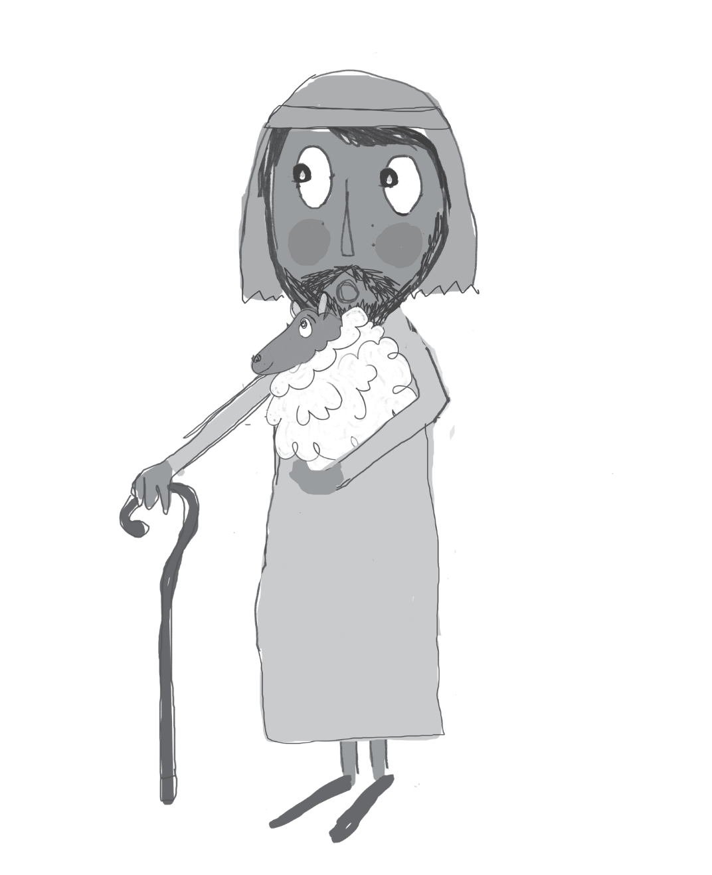
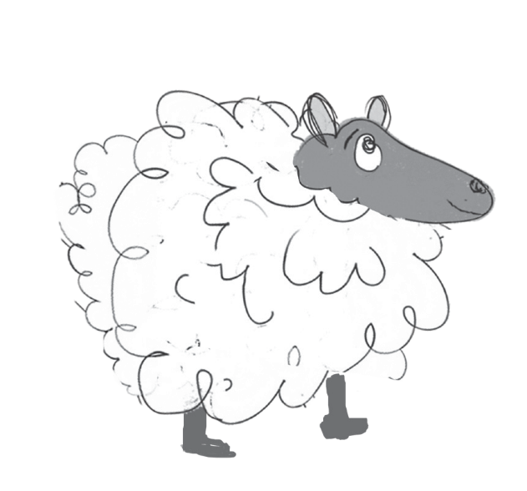
(insert school name here) staff room that might be good for us. (They exit)

THE END

